**CODING TEST - 2 (PYTHON)**

VAIBHAV PATIDAR

20/12/2023

**Q1. Explain Python modules, create a module, import it and rename it :**

* Python modules are the files, which contains executable code, classes, objects and several stuff, which can be easily imported in other files and all of its content can be used there.
* Python modules are of 2 types : User Defined modules & System defined modules.

**→ CREATING A CUSTOM PYTHON MODULE : *infoModule***

*[It will contain the info of a employee, such as its → id, name, years of experience, and a function, and a class which allows us to set the salary of employee]*

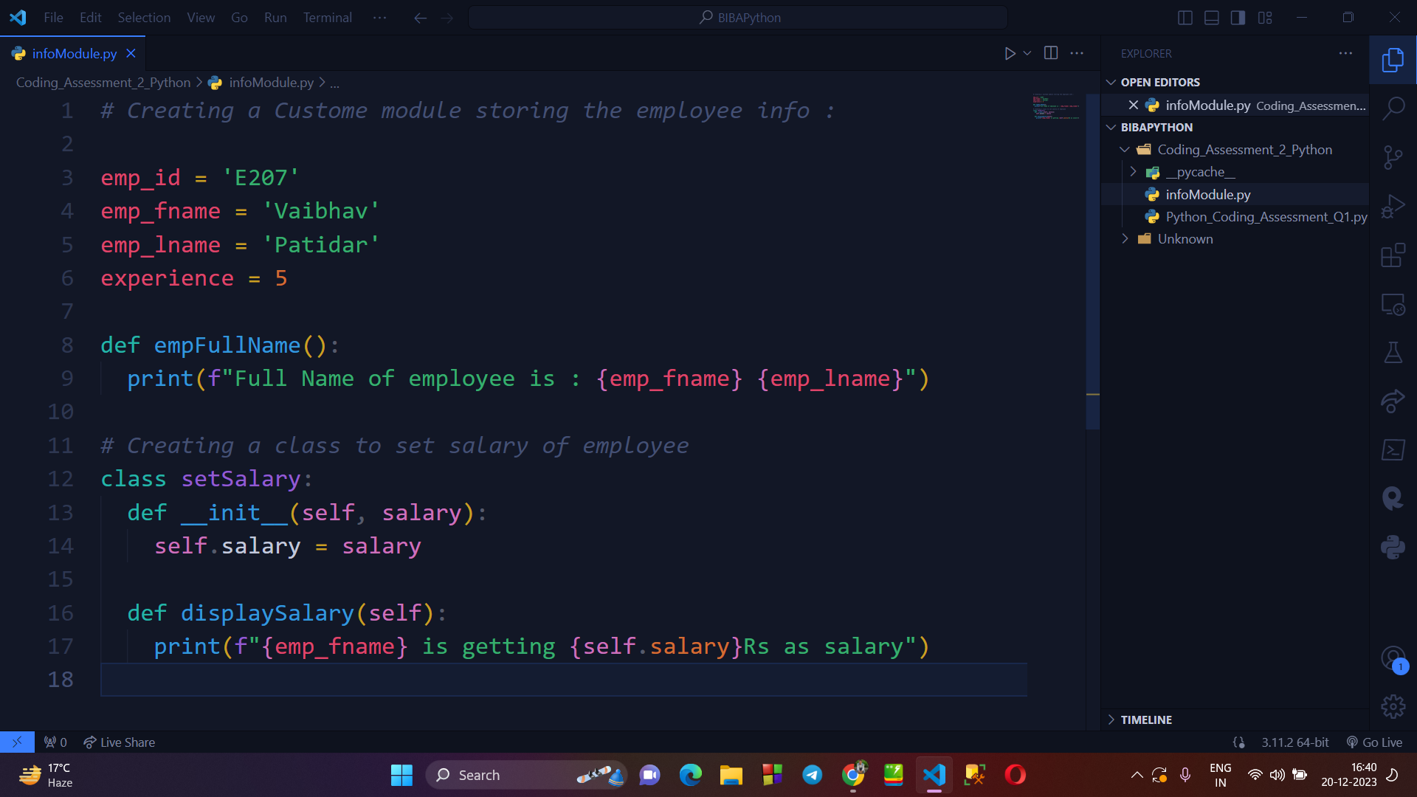

→ **IMPORTING THE MODULE AND ACCESSING THE METHODS / CLASS & ATTRIBUTES :**

*[Here, I have imported the infoModule in another file named → Python_codng_assessment_Q1.py , where I’ll fetch and print the basic detail of employee and then I’ll create an object of setSalary Class and defines a new salary of employee]*

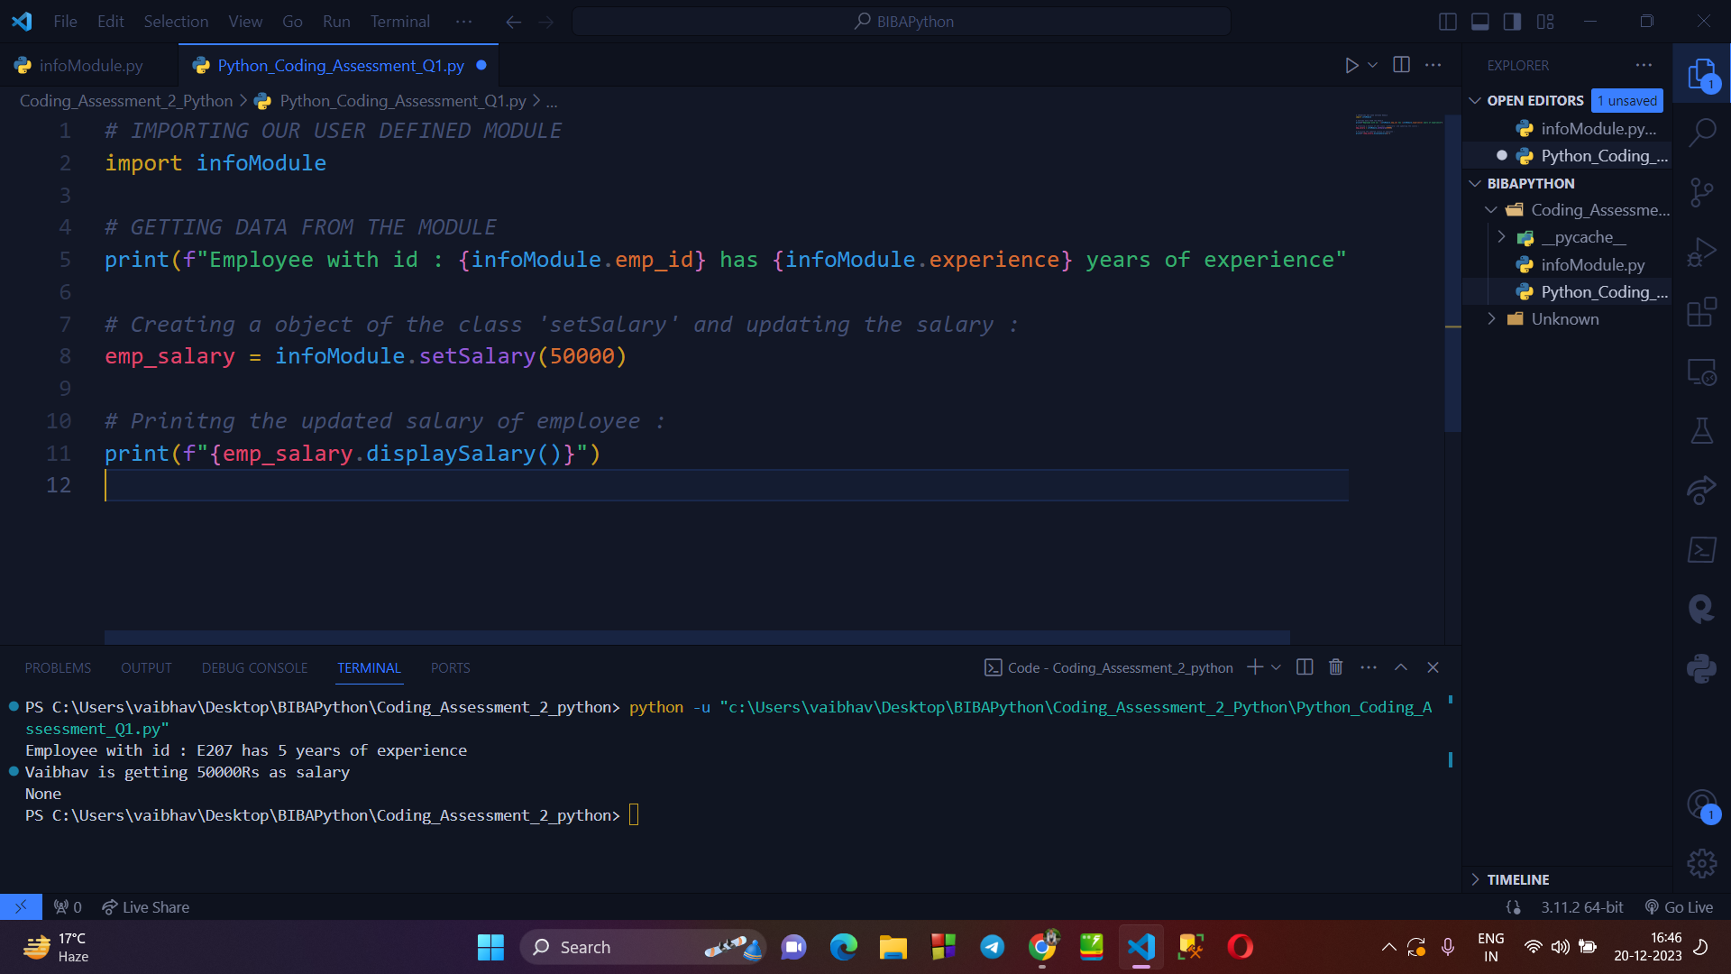

**→ UPDATING THE ATTRIBUTE OF MODULE FROM ANOTHER FILE :**

*[Here, I’ll update the experience attribute of infoModule* *and then I’ll print the updated value of experience]*

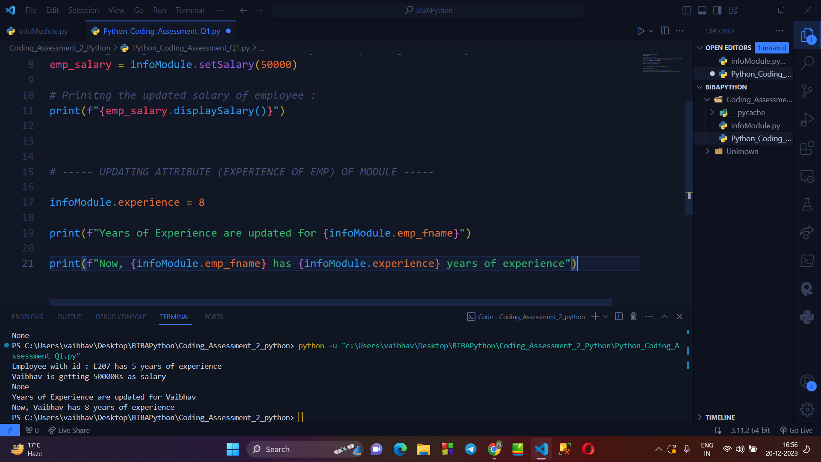

**→ RENAMING THE MODULE :**

*[Here, I’’ simply rename the infoModule to empInfoModule while importing it, so that I can use it with its new name, wherever required in our code. I’’ll fetch the data similarly I did before , to show its working.]*

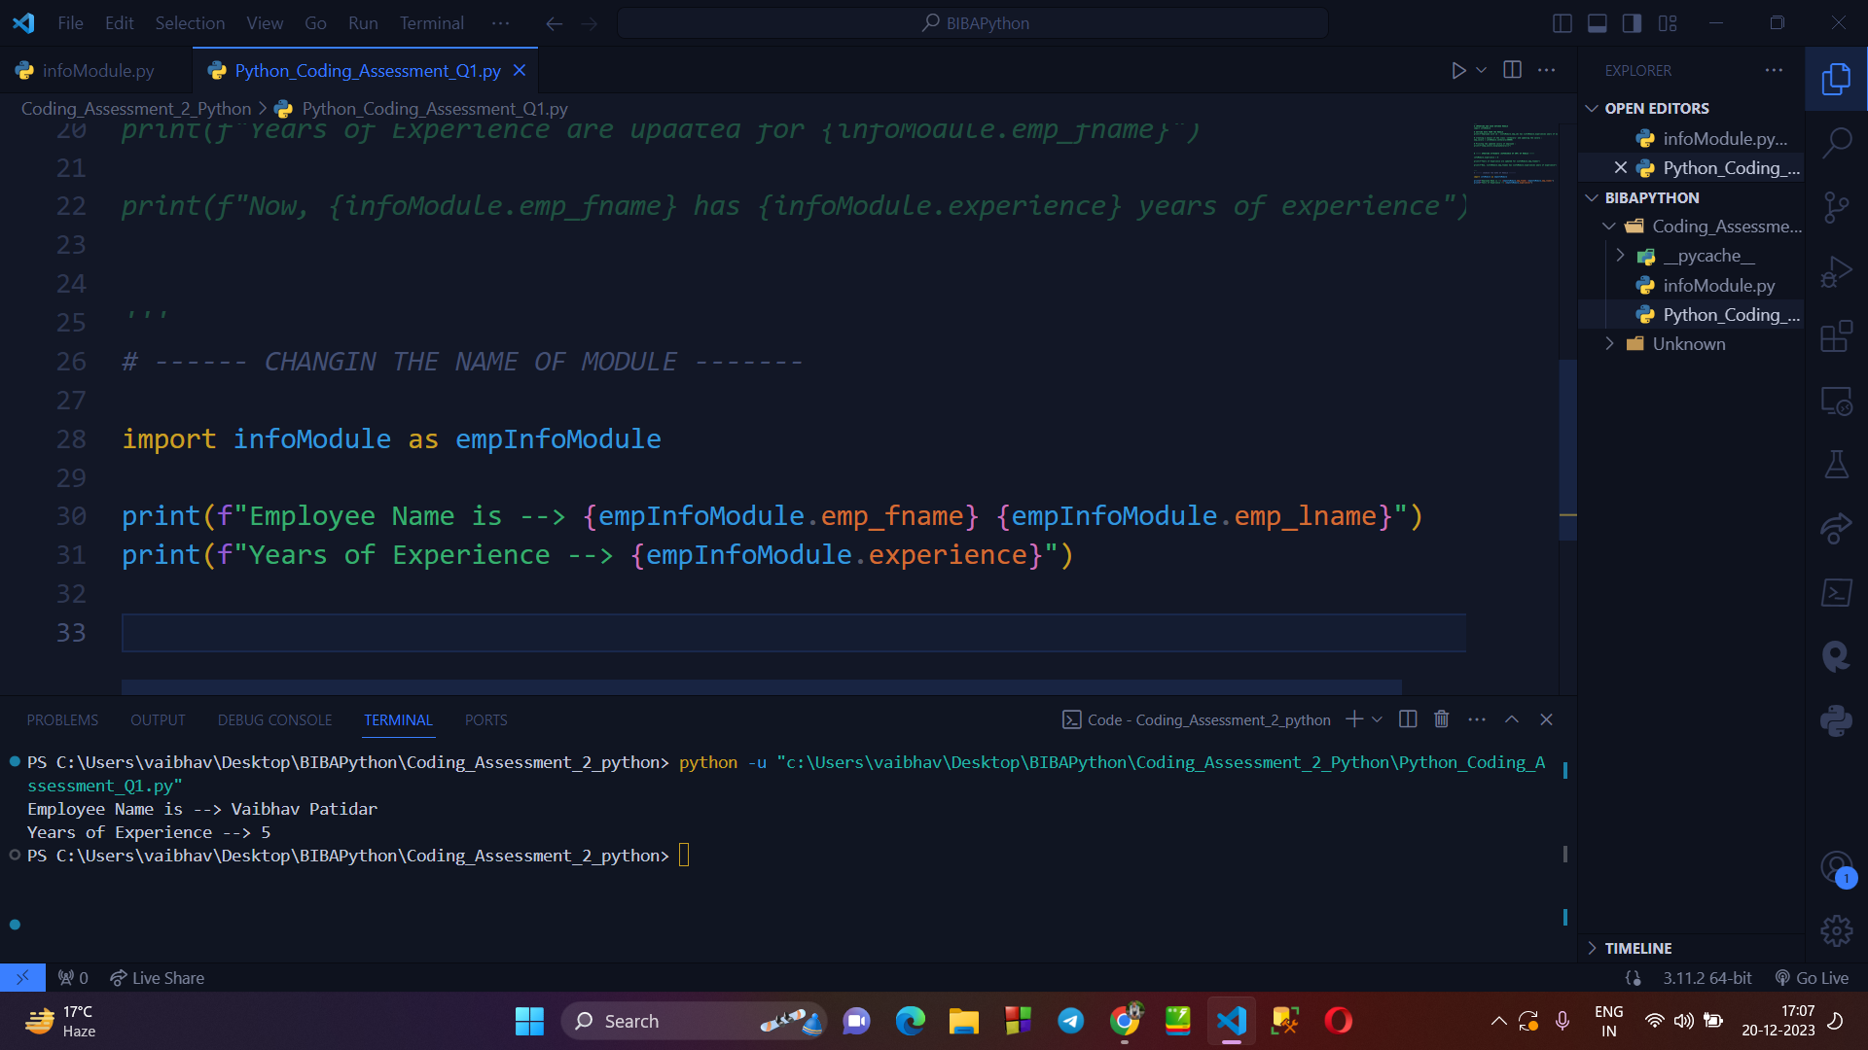

***—--------------- QUESTION 2 —-------------***

**Q2. Explain use of PANDAS and NUMPY with examples.**

**>PANDAS :**

**→ IMPORTING THE COLUMN NAME OF A CSV FILE :**

*[Here I have create a CSV file named ‘’Student_data.csv’ and I’ll read the data using* ***pandas*** *and print the column name first]*

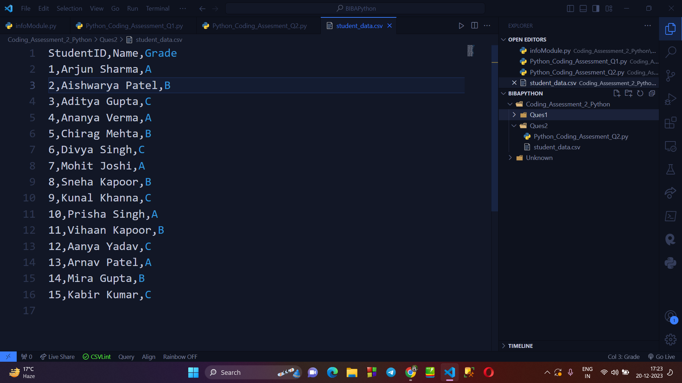

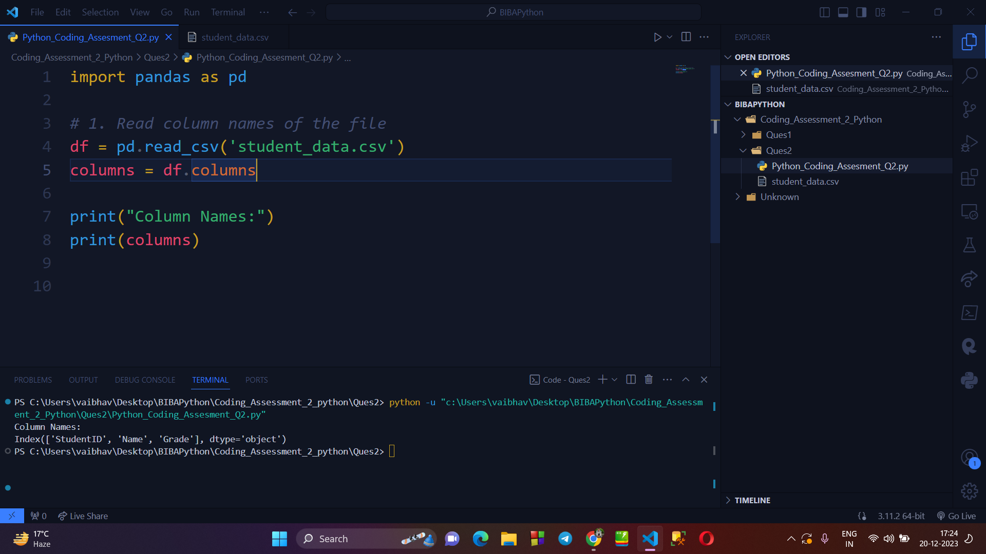

**→ IMPORTING WHOLE CONTENT OF THE CSV FILE :**

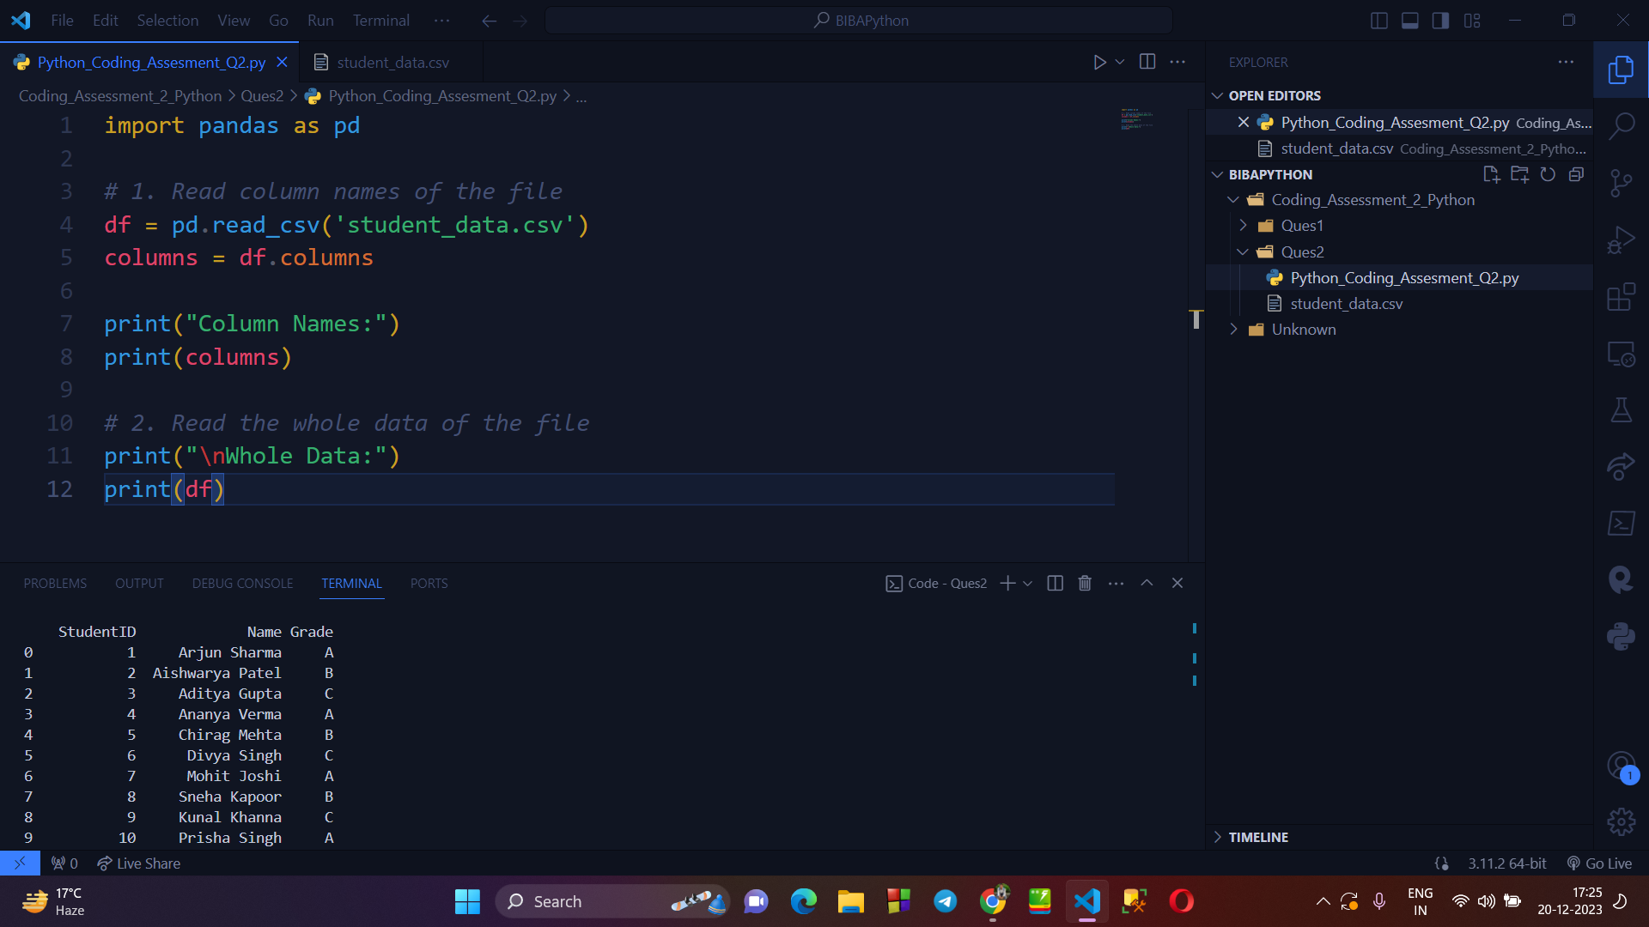

**→ APPLYING FILTERS AND SORTING ON CSV FILE :**

*[Here, i’ll print the student’s details having A grade]*

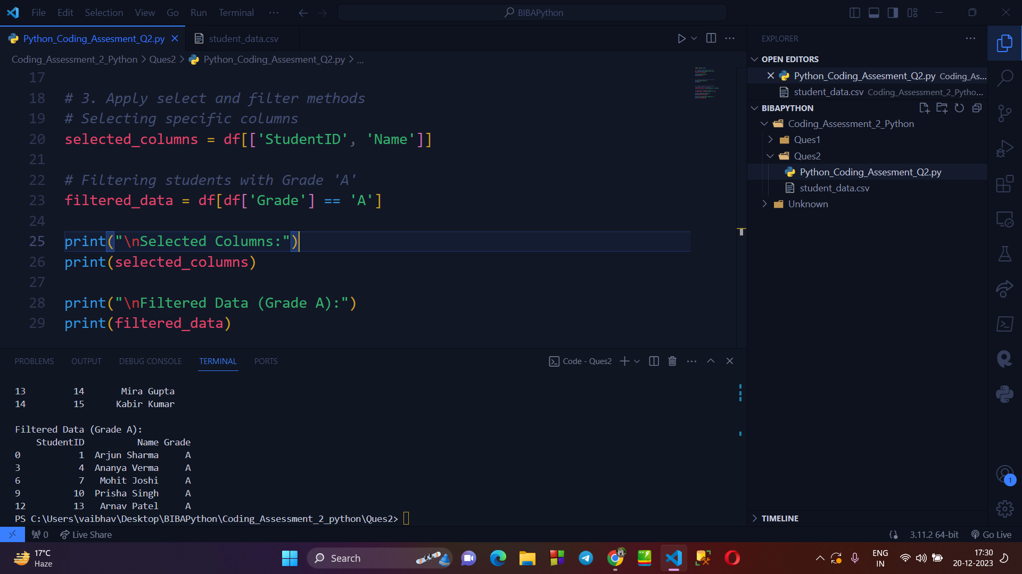

**> NUMPY :**

**→ CREATING A 1-D & 2-D ARRAY USING NUMPY :**

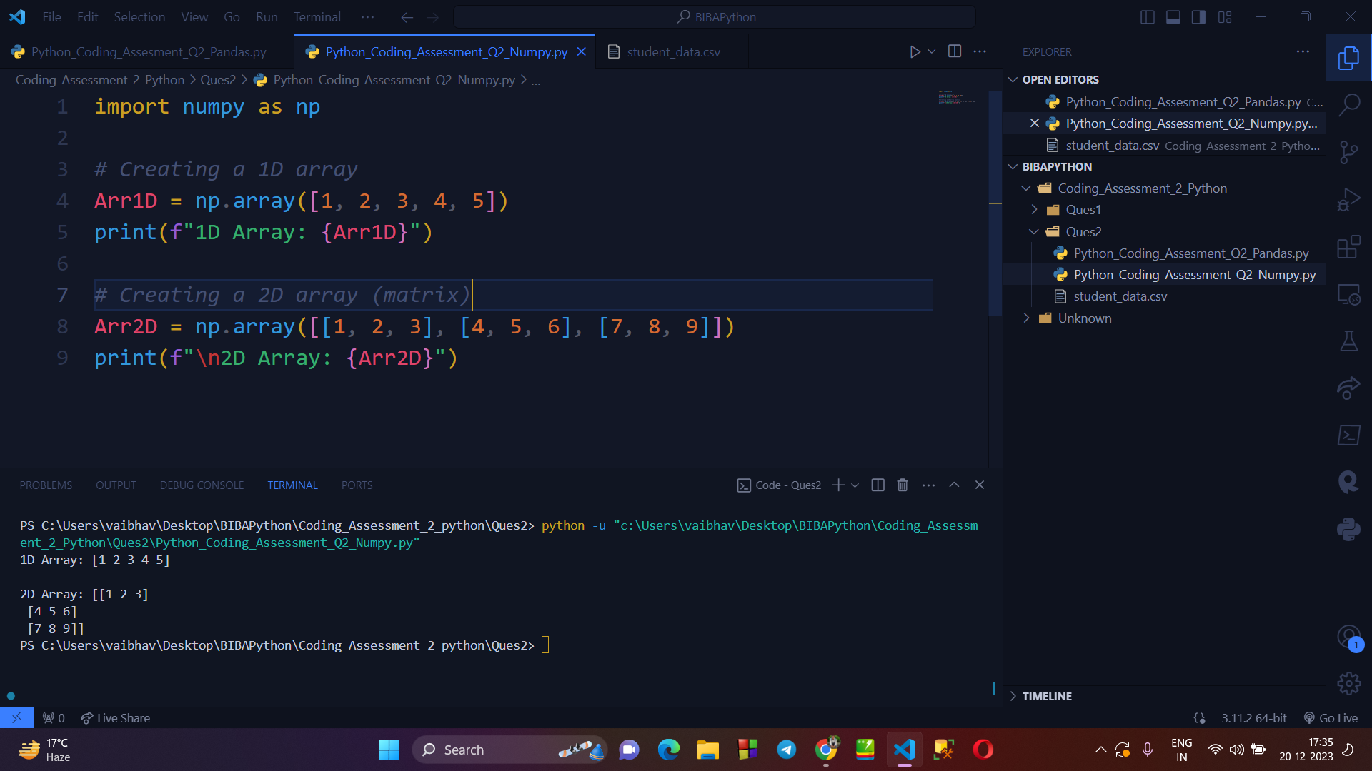

**→ APPLYING ARITHEMATIC OPERATIONS ON 2 1D ARRAYS :**

*[HERE, i have apply the basic arithmetic operation i.e. ADD, SUBTRACT, MULTIPLY & DIVIDE on 2, 1d arrays using numpy.]*

